After six weeks of intense nursing, veterinary tests and treatments including careful dieting, neutering, removing thick wadded mats of filthy coat, flea treatment and skin care, along with worming, we are happy to report that one male and three females where thought to be sufficiently well enough to be Adopted, or at least Fostered. Aleks and Carole have pulled out all the stops and put their hearts into care, feeding regimes, and rehabilitation, as have the Foster carers of a couple of the dogs.
Carole took two of the bitches into her care, she says, ‘My heart almost broke when I got home and took them into the quarantine area ready with beds and fresh water bowls. Both girls ran straight past the water bowls to put their heads in the toilet as they saw that as the source for water.
Bob and I then fed the girls. There was desperation and fear in the way they ate. A half bowl of water was put down every 1/2 hour and they were taken out every hour on the hour for the next 24 hours, until their desperation for water was reduced.
Their next major need was to be relieved of their disgusting filthy coats so as to better assess their needs and make them comfortable. I tackled the young standard poodle (temporarily named Candy) on the first evening. I could find no flesh covering the bones, every rib was visible, there were clear signs of dehydration around the eye sockets, and it was difficult for her to see or hear. Poo was found under her chin around her ears and in hard balls under her feet.
Next for the old girl (named Tilly) she was not starved but thickly matted and filthy infested ears lay under the mats. Tilly was showing worrying signs of kidney problems. They were then booked in at the vets without delay.
They were assessed, weighed, and received treatment for their ears. Candy, now properly hydrated, was just under 12kg: at 20.5 inches, dangerously underweight. A low protein raw diet was approved by the vets to help kidney function.
Over the weeks they have received treatment for giardia, fleas, ear mites, round worm, and tape worm. They have also now both been spayed. Tilly and Candy are now well on the way to reliable house training and can be walked on a lead. It is a testament to their wonderful natures that they are happy in each other's company, sleeping close together and are still capable of loving their carers and any grandchildren that visit. Their health and spirits have been much restored, they adore cuddles, sofa surfing and playing in the garden but they still have a long way to go for Candy to put on weight and Tilly to face the world without fear.’
Aleks Update, ‘I could write a small book about all the challenges and difficulties we have faced over the last few weeks, truthfully when I was asked to write something for you all as an update, I didn’t even know where to begin. The mental, emotional, and physical impact has been enormous, but I’m thankful to have been in the position to be able to offer immediate help to four of the poodles, three of which are doing brilliantly in their new foster homes, and one of which has stayed with me to be fostered as she will need longer to recover.
There have been many challenges along the way and the road to recovery for all these poodles has only just begun, their bodies will need a long time to heal from the prolonged dehydration, ear infections, urine burns and extreme starvation. But it’s not just their bodies that need to recover, many of these dogs display behaviours typically associated with physical abuse, and being cage bound, their knowledge of the outside world and normal life is none existent or minimal at best.
Despite the trauma, from the day we rescued these poodles, they’ve been nothing but kind, sweet and loving towards every single person they’ve met. They have all made huge amounts of progress in such a short time, such as putting on weight, learning about toilet training, basic manners and just how to be a dog.
This rescue has been incredibly hard on all of us, but I cannot thank everyone enough for all the support. These poodles finally have the life they deserve, being shown love and having a full tummy, and it’s thanks to all of you that have been so caring and kind to donate towards their welfare.
Our ‘cover girl’ as I’ve been calling her, Khali, the extremely emaciated silver girl, is doing fantastically well given her condition. She weighed just 10kg at 22 inches. She was the first dog I clipped as I could feel that under the layers of matted faeces all I was going to find was bones, and I needed to see immediately what we were dealing with. Nothing could have prepared me for what I uncovered, and I hope I never have to see it or smell it again. Throughout the few hours of carefully peeling layers of dirty felt off her, this sweet girl didn’t object at all. She went to see the vets that same day as I was extremely concerned for her life.
This girl’s spirit and character was still firmly holding onto life. In the weeks since the rescue, Khali has not only put on weight, regained energy and generally started acting like a dog again, but she has also been a pain in my back side with her larger-than-life personality, sass and a sense of entitlement which I didn’t think would be present due to her past life, but she’s a standard poodle after all so I don’t know why I’m surprised.
Khali has been extremely busy discovering many hobbies. Her first hobby has been joining in with the daily howling sessions of a pack of hounds that live next door. Subsequently then deciding that one daily howling session isn’t enough and taking it upon herself to encourage the hounds to howl not twice but three times per day, on a schedule only known to Khali. At no point would she of course leave the comfort of the sofa, she would merely just sit up and begin the howling session at her convenience. She has contained the howling sessions to daytime hours only which I and the whole village are very thankful for.
Her second hobby, the most beneficial, safe and least inconvenient for me and my neighbours, is the discovery that walks are fun, playing in water isn’t for her, having wet paws is disgusting and drinking an entire lake is in fact not possible (she tried her best though).
Her third hobby of eating random things has brought us a bit of worry, as she proceeded to eat 31 inches of continuous fabric that she tore off the sofa. This gave us and the vet a fright with two intensive days of Khali being ill, but worry not, our spirited girl pushed through with the fabric thankfully coming out in its entirety at 1am, at which point Khali felt much better, proceeded to have the zoomies, started off yet another howling session and announced she’s very hungry.
Going back to her sense of entitlement, Khali now strongly believes that dog beds are for peasants and sofas are the only acceptable option for sleeping arrangements. I have managed to negotiate a deal where she spends night time on the dog bed but promptly moves to the sofa during the daytime. If at any point the sofa space is unavailable, she makes her displeasure quite clear by sitting in front of us attempting to stare us down and puffing out her cheeks, adding in the occasional dissatisfied grunt. Her current attempts at this technique have been fruitless as boundaries are important in this household, but as I mentioned earlier, this girl doesn’t give up easily.
We’re not out of the woods yet, there’s no telling how much long term damage has been done to her body, but she continues to show us all every day, that life is worth living, never give up and always try to push the boundaries because you never know, it may just be your lucky day and the human might cave and share their dinner with you (or so she hopes).
Their have been 92 separate donations. The Standard Poodle Club Rescue would like to sincerely thank all our members, and friends for their kind support over the years, which enables us to cater for any Rescue dog that is given up for our care.
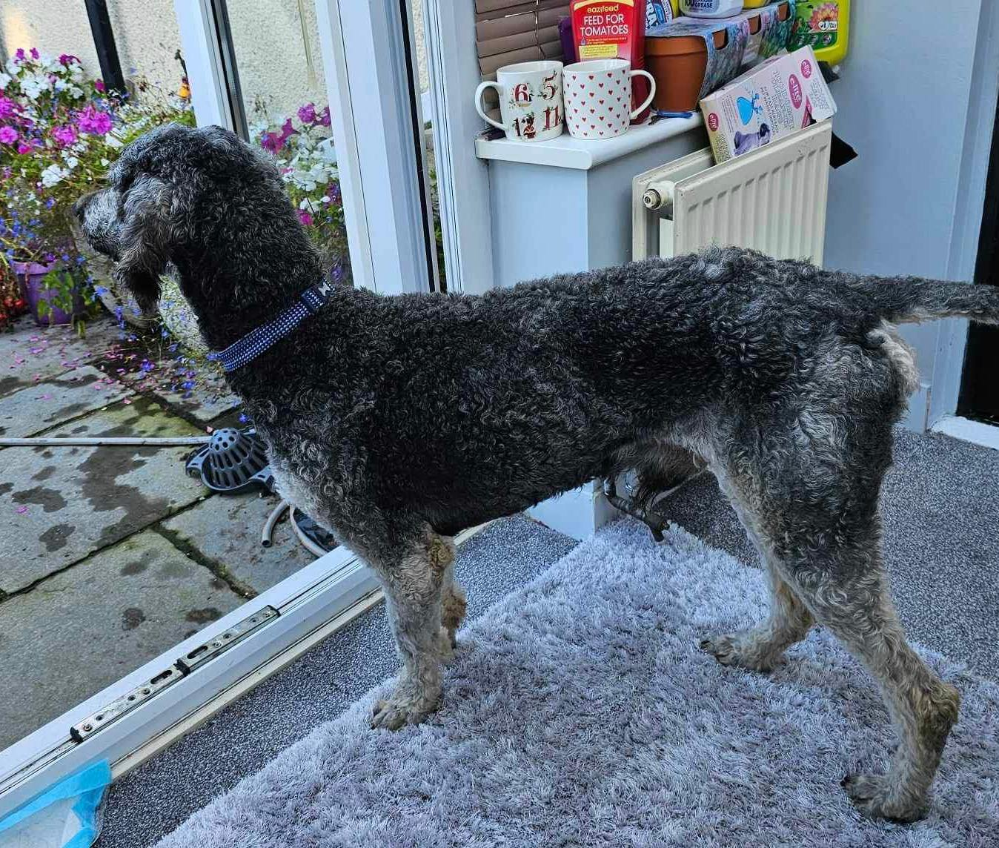

Bengi after 6 weeks care
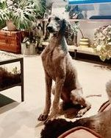

Khali after 6 weeks care
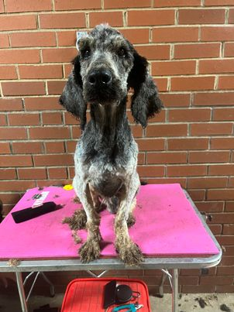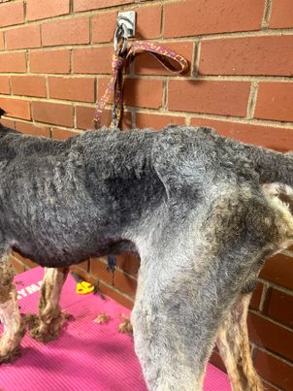

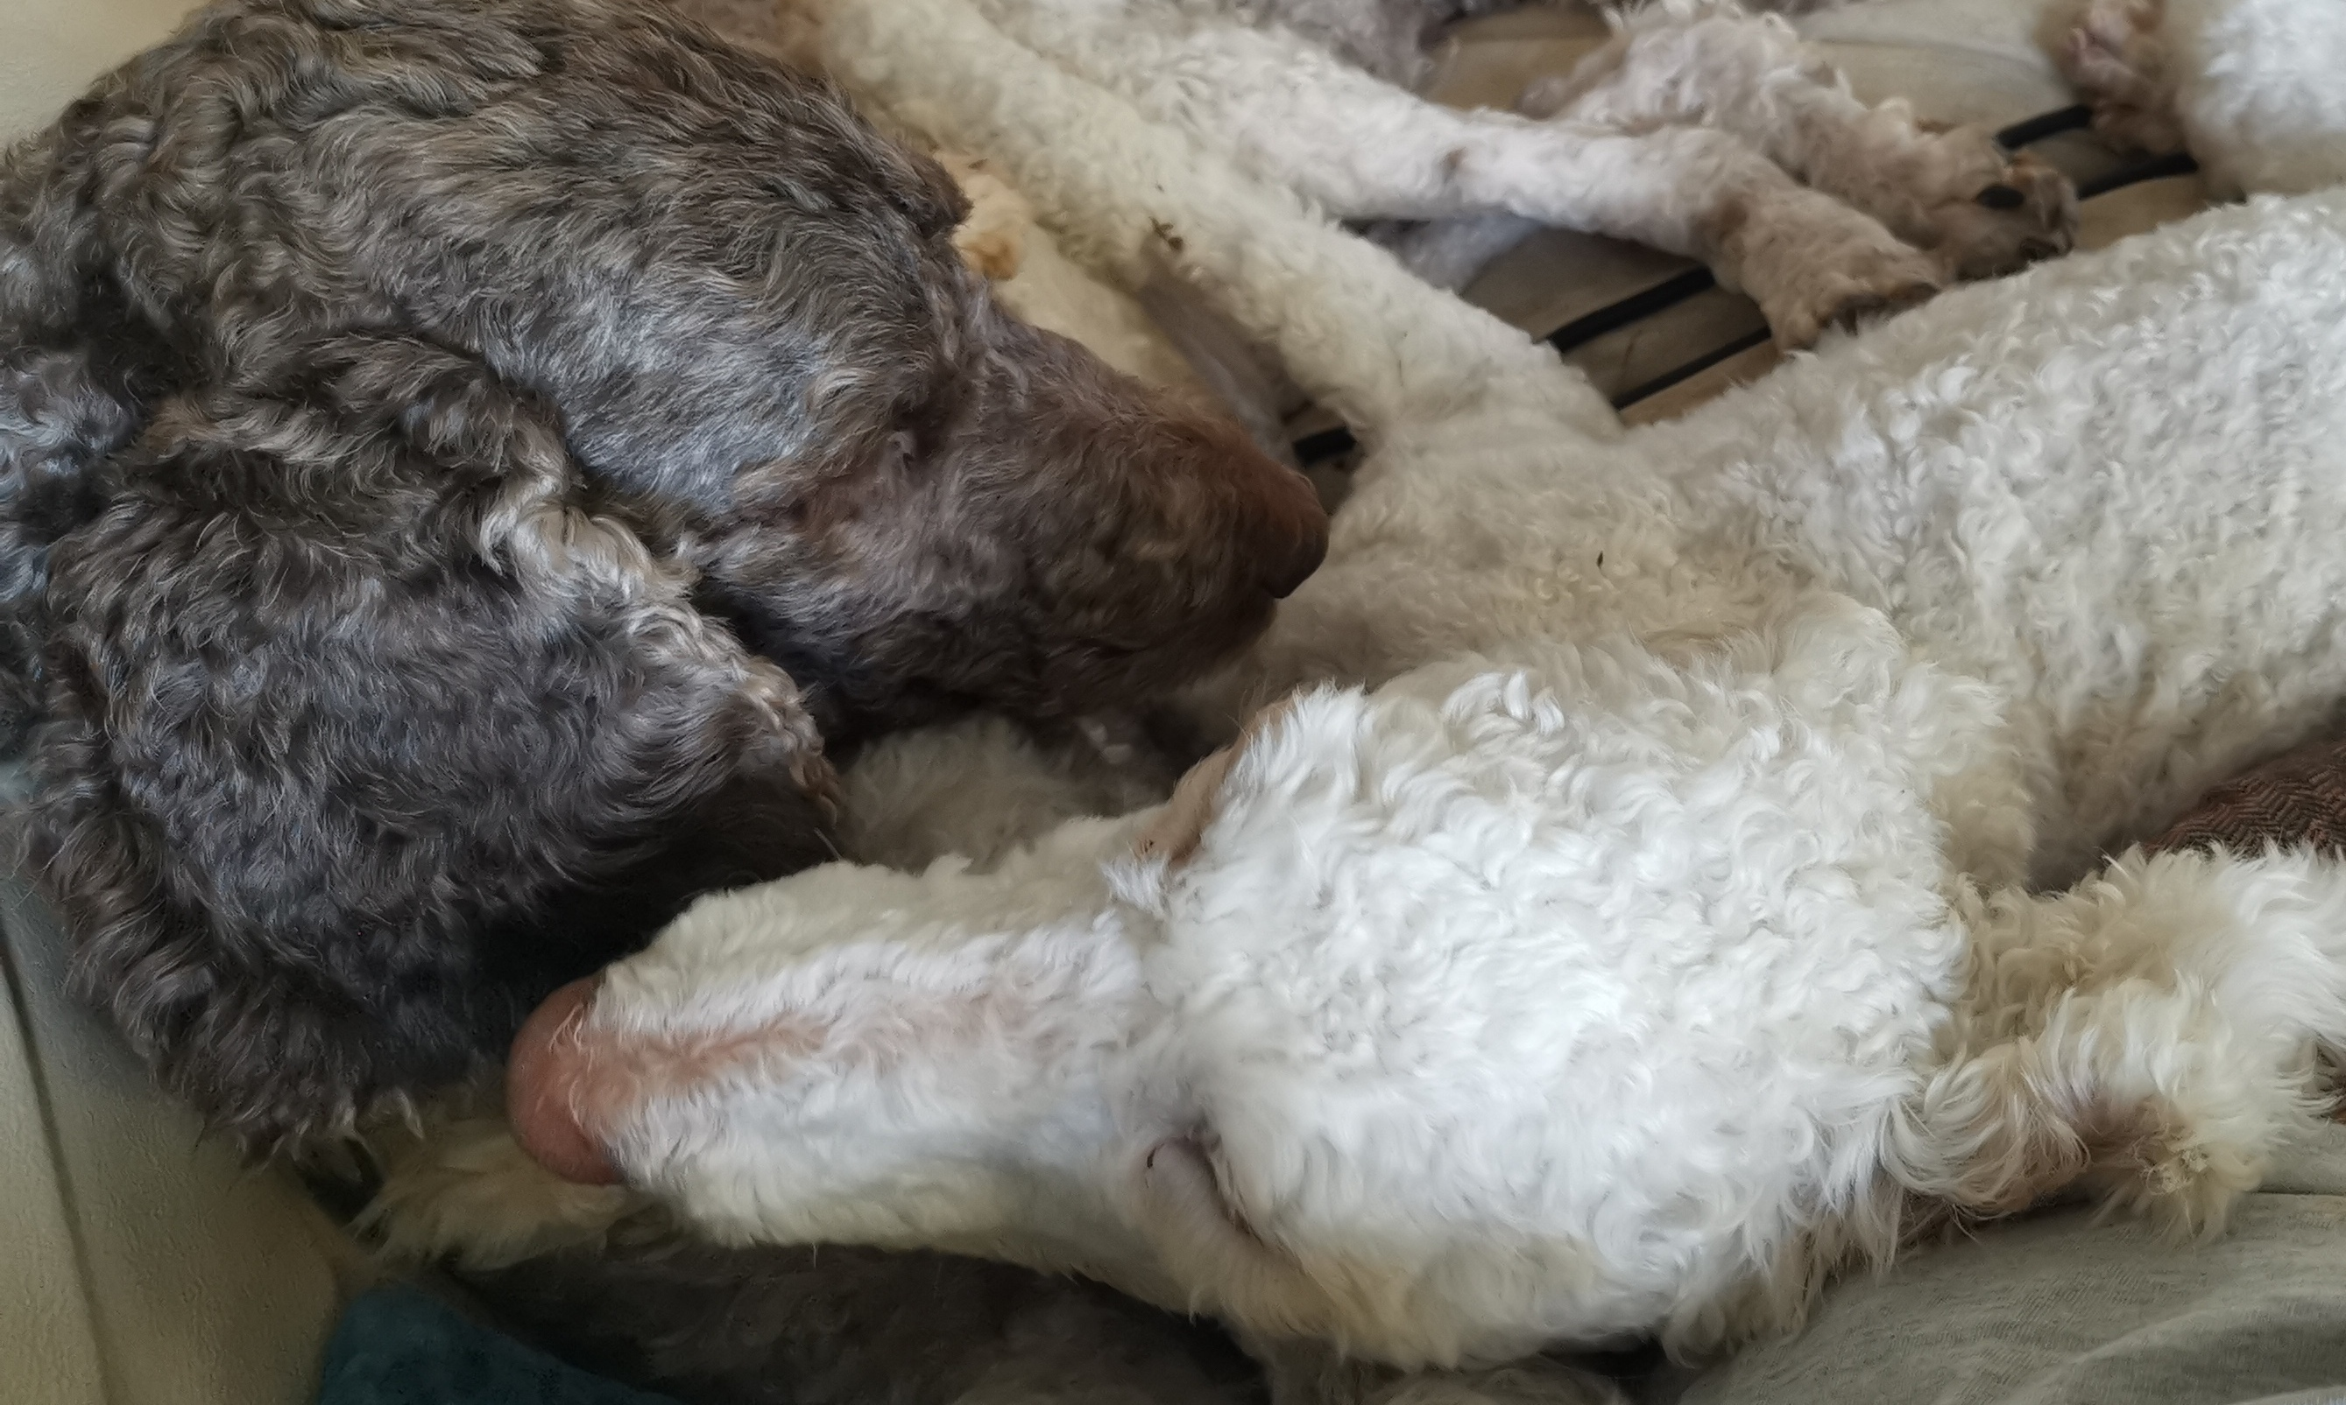

THE STANDARD POODLE CLUB RESCUE

