The Standard Poodle Club Rescue

The Poodle Network UK rang asking if the Standard Poodle Club Rescue could possibly help in the rescuing of Standard Poodles, as they were collecting what they had been told were 15 or more Poodles of various sizes and they only had space for 12 dogs. The dogs, they said, had to be removed from the premises with immediate urgency. We agreed to help. Committee member Aleks quickly offered the use of her kennels until we could get the dogs sorted.

Our club Secretary Mary and Eileen went to the premises to meet the representative of Poodle Network UK, Julie, and Aleks, who had arrived to collect the dogs.

The horrific scenario that faced us was dirty, filthy, some soaking wet, undernourished dogs and bitches. Aleks had been on site for some time when Mary and Eileen arrived at about 9-30am. She had managed to scan some of the females and found that at least four of them were in whelp. One of which, was nearing her whelping time and looking worryingly malnourished. All the dogs reeked of stale urine, faeces, and sick, and most had obviously not been brushed, clipped or generally attended to for some months. Most of the dogs we saw had neglected coats matted to the skin and it was impossible for them to toilet naturally as the thick wads of wool coat was stinking and full of faeces, and glued to their genitals. Some of these dogs were so weak they couldn’t stand or walk with any ease.

Our Health Officer, Carole Grundy had said she could house two females, so the eldest, which was ten years old, and a younger two-year old were selected. They were nervous but not unfriendly. We put these two into the car ready to leave as we were meeting Carole on the A1 to hand them over. We helped Aleks load the others. We took six in all, as there were more dogs on the premises than we thought. We agreed to take extra to relieve the situation for Poodle Network.

Even then, knowing that the dogs were thin and severely neglected, the full extent of the horror faced us later. Aleks decided when she got the dogs back home to start to clip off the stinking, filthy, matted fur of the silver bitch, where, to her utter despair she found the bitch was no more than literally a skeleton. She immediately rushed the bitch to the vet.

Finding one of the males crippled and deformed once his filthy, flea- ridden, matted coat was removed, and also having a body of a skeleton, Aleks took him to the vet the next morning. Both these dogs were infested weak and emaciated. It is considered that the dogs had experienced extreme cruelty that can cause psychological and physical damage.

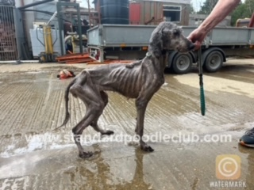

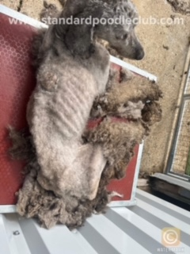

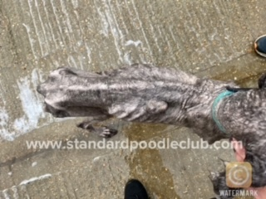

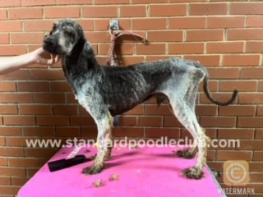

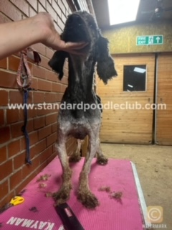

The next morning Mary and Eileen went to Alek’s home to help her clip the coats of the other two dogs, a male and a female. Whilst these were obviously undernourished, and flea ridden, they were not in a dangerous state, although the female was so matted she could not relieve herself without the offending matter seeping further into her coat.

Aleks has been visiting the vet for tests and treatments for the four dogs in her care, and feeding a planned, controlled diet,

All the dogs will be neutered and constantly assessed with the view of placing them in a permanent home once they are sufficiently healthy.

The Standard Poodle Club Rescue would like to sincerely thank all our members, and friends for their kind support over the years, which enables us to cater for any Rescue dog that is given up for our care.

Frequently asked questions;
How are the dogs now?
All the dogs in our care are receiving the best care, are under close supervision and improving daily.
Where are they?
The dogs are with volunteers from SPC and PNUK around the country
How can I help?
Become a member of SPC (download membership form on website below or contact our Secretary) or send donation to Standard Poodle Club sort code 40 24 37 account 51201557
Who is responsible and will they be held accountable?
This is being dealt with.
When can they be re-homed?
It may be some time before they can be re-homed
What should I do if I know of other dogs in this situation?
Contact your local representative (website link below) who will offer a confidential re-homing service
How does re-homing a rescue dog work?
Your area representative will send email a document. You fill in the details age, habits, reason for rehome, colour etc and we find a suitable home.
Is there any fee for this service?
No, it is completely free of charge
How can I offer a home to a rescue dog?
Your area representative will email you an enquiry document. You fill in your details, situation, etc and after a home check when a suitable rescue becomes available, we will contact you. Max donation is £300
How can SPC afford to operate this service?
Thanks to the membership (£7 per annum) generous donations and legacies.

www.standardpoodleclub.com

